Enhanced Dynamic Window Approach for Socially Compliant Robot Navigation.
Ashwath S¹, Mayank R², S. Pavithra³
1School of Computer Science and Engineering, Vellore Institute of Technology, Chennai, Tamil Nadu, India
ashwath.shivram2022@vitstudent.ac.in, mayank.raj2022@vitsutdent.ac.in

ABSTRACT As autonomous mobile robots proliferate in human centered settings, their social complianc specifically, their adherence to norms such as proxemic becomes increasingly important for their adoption. While contemporary deep learning methods are frequently computationally costly and lack the interpretability required for safety-critical applications, traditional local planners, like the Dynamic Window Approach (DWA), are essentially constrained by their purely geometric, "socially blind" nature. By adding a critical layer of semantic knowledge to the traditional DWA, this research introduces Semantic-DWA, a unique, lightweight, and interpretable framework that closes this gap. A perception function that categorizes obstacles into categories like "pet," "person," or "object" and a direct change to the DWA's basic cost assessment function are the two main components of our methodology, which has been proven in a lightweight Python-based 2D simulator. established a "social cost" that assigns an endless cost to any trajectory that deviates from the predetermined proxemic zones for each obstacle class. In order to provide a workable solution for safer and more natural human-robot coexistence, this paper describes the full design of a computationally tractable and easily verifiable method for adding social intelligence to a proven local planner.
INDEX TERMS Socially Aware Navigation, Dynamic Window Approach, Semantic Navigation, Proxemics.
- INTRODUCTION
The growing number of self-governing mobile robots operating near people—in places like homes and hospitals—means their navigation systems must do more than just avoid collisions. To be accepted by society, these robots need to move in ways that are predictable, easy to follow, and respectful of unwritten human social rules. The Dynamic Window Approach (DWA) is a basic, popular algorithm known for efficiently preventing crashes based on object geometry. However, the standard DWA is "socially unaware," treating every obstacle on its map as the same risk. This failure to tell the difference between an object and a person often results in routes that are socially unacceptable, violating a person’s personal space (proxemics), and causing people to lose trust and feel uncomfortable.
To fix this flaw, researchers have looked into advanced methods. For instance, Inverse Reinforcement Learning (IRL) has been used to learn how humans cooperate during navigation, capturing the probabilities of both navigation decisions and path variations. This allows robots to copy or anticipate human actions, resulting in movements that comply with social norms [26]. Related work uses Feature-Based Prediction of Trajectories to help robots infer the underlying probability of human behavior from observations, enabling them to react appropriately to predicted interactions [27].
While powerful, these solutions often have major drawbacks, such as needing a lot of computing power and being difficult to interpret. A promising way to bridge this gap is by using semantic information, where a robot uses knowledge about what an object is, rather than just where it is, to guide its decisions. By adding descriptive labels to a robot's world model, it can apply rules specific to a particular context. Semantic-Assisted SLAM (Simultaneous Localization and Mapping) has been explored to make maps better by using semantic data to filter out moving objects, providing a more stable base for navigating dynamic environments [28]. Furthermore, studies have shown the value of putting semantics directly into the local movement planning: Semantic Priority Navigation uses a simple neural network to categorize obstacles (like people or machinery) and assign different safety margins or "risk-weighted" costs to the local planner based on the obstacle's identity. This is a crucial step toward integrating context directly into a reactive avoidance system [29].
This paper introduces a new framework that addresses this research need by improving the basic DWA with a simple layer of semantic understanding. Our approach avoids the complexity of prediction and deep learning models by directly changing the DWA's cost function based on explicit classification of obstacles. We designed a modular system where a perception unit first identifies and labels obstacles as either 'dynamic' (moving) or 'static' (still). This semantic information then allows our modified DWA to apply a class-based "social cost," which penalizes paths that trespass on predefined proxemic limits differently for each category. This paper details the design and implementation of this framework, offering a practical and clear way to give a proven local planner necessary social intelligence.
- Related Works
The development of autonomous systems capable of navigating human-centric environments is a prominent and actively researched field. This review examines the contemporary literature, focusing on four key areas relevant to our work: the overarching challenge of social navigation, recent enhancements to the Dynamic Window Approach (DWA), the prevalence of learning-based solutions, and the emerging role of semantic context in motion planning.
- The Challenge of Socially-Aware Navigation
Modern robotic navigation has evolved beyond simple collision avoidance to address the complex nuances of operating in human-shared spaces. A comprehensive survey by Möller et al. highlights the core challenges in human-aware robot navigation, emphasizing the need for behaviors that are not just safe but also predictable and socially acceptable [8]. The concept of "social compliance" has become a central theme, extending from mobile robots to automated vehicles, with frameworks being developed to ensure these systems adhere to implicit social rules [2]. A critical component of this is understanding proxemics, or personal space. Recent studies have investigated these proxemic norms in specific contexts like construction sites [9] and have explored using social zones as explicit "barrier functions" in planning algorithms to enforce non-intrusion [1]. Research also focuses on understanding the subtle differences in pedestrian behavior when interacting with autonomous versus human-driven agents, which is crucial for creating systems that feel natural and trustworthy [10]. The ultimate goal is to achieve a level of "natural intelligence" that fosters human-centric adoption and seamless integration of autonomous agents into daily life [6].
To address these intricate social challenges, researchers have employed a wide array of planning paradigms. Beyond DWA, popular methods include other reactive planners like the Velocity Obstacle (VO) approach, which reasons about the collision cones of dynamic obstacles to ensure compliance with traffic regulations [23]. More deliberative strategies involve optimization-based techniques such as Model Predictive Control (MPC), which can plan safer trajectories over a longer horizon [25], and high-level routing algorithms based on dynamic programming for complex scheduling problems with time windows [24]. A significant challenge within this domain is accounting for the varied and often unknown social preferences of different individuals, which recent studies have begun to address [4].
- Recent Enhancements to the Dynamic Window Approach (DWA)
The Dynamic Window Approach (DWA) remains a foundational algorithm for local, reactive planning, and its adaptability has made it a popular subject for modern enhancements. Recent research has focused on tailoring DWA for specific and complex applications. For instance, it has been improved for use in agricultural robots navigating orchards [11] and for dynamic obstacle avoidance in other agricultural contexts [12]. Beyond single-robot applications, DWA has been adapted for mobile robot formation control [13] and extended into three dimensions for efficient UAV navigation in confined environments [15]. These improvements often involve integrating other techniques to augment the DWA's core logic. For example, Yao et al. combined DWA with fuzzy logic control for energy consumption management [14], demonstrating the planner's flexibility. This body of work confirms that modifying and enhancing DWA is a current and highly relevant research direction for solving modern navigation challenges.
- Learning-Based Paradigms for Navigation
In parallel with enhancements to classic planners, end-to-end learning-based approaches, particularly Deep Reinforcement Learning (DRL), have become a dominant paradigm for navigation in dynamic environments. DRL methods have shown success in modeling and simulating dynamic obstacle avoidance for autonomous vehicles [17] and optimizing reward functions for navigation in complex scenarios [16]. Advanced DRL techniques are also being developed to handle the inherent uncertainties of real-world environments, such as in the navigation of unmanned surface vehicles [18]. A key advantage of these methods is their ability to learn complex behaviors directly from data. Inverse Reinforcement Learning (IRL), for example, can be used to infer the intentions and preferences of human road users by observing their actions around autonomous vehicles [7]. While powerful, these data-driven approaches often function as "black boxes," making their decision-making processes difficult to interpret, a significant drawback in safety-critical systems.
- The Role of Semantic and Context-Awareness in Planning
A third and highly promising direction is the integration of semantic understanding into the navigation process. This paradigm shifts the focus from purely geometric representations of the world to a richer, context-aware model. Recent work has demonstrated the power of deep semantic segmentation for enabling GPS-free navigation in challenging environments like cluttered tree rows [19] and for extracting navigation lines in agricultural settings [21]. Semantic information can also be fused with traditional SLAM (Simultaneous Localization and Mapping) to enhance navigation robustness in unstructured environments [20]. This allows robots to perform more advanced tasks, such as automated inspection and environmental monitoring, by understanding the objects they are interacting with [22]. The state-of-the-art in this area is now exploring the use of Large Language Models (LLMs) to achieve an even deeper level of context-aware decision-making based on social behavior modeling [3]. By grounding planning decisions in an understanding of what objects are, semantic navigation offers a path toward more intelligent, reliable, and interpretable robot behavior, highlighting a clear opportunity to enhance classic, reliable planners with a lightweight layer of semantic intelligence.

- III. PROPOSED METHOD

This section comprehensively details the proposed framework for socially-aware robot navigation, which integrates a perception function for semantic classification, a social disqualification rule for proxemic awareness, and a modified Dynamic Window Approach (DWA) local planner implemented in a lightweight Python simulation. The entire pipeline aims to produce socially compliant trajectories that respect human personal space, while maintaining the computational efficiency and reliability of the classic DWA. The sequential data flow of these components, from environmental perception to final velocity command, is conceptually illustrated in Figure 1. The core logic of this integrated perception and planning cycle is presented in a unified Algorithm 1, with each step further elaborated in the subsequent subsections.

Algorithm 1: Semantic-DWA Simulation Cycle
Input: Current_Robot_State, Goal_Position, List_of_All_Obstacles.
Output: The optimal, socially compliant velocity command, Optimal_Velocity_Command.

- Possible_Trajectories ← GENERATE_TRAJECTORIES(Current_Robot_State)
- Min_Cost ← INFINITY
- Best_Velocity ← Current_Robot_State.velocity
- FOR EACH trajectory IN Possible_Trajectories
- is_socially_invalid ← FALSE
- FOR EACH obstacle IN List_of_All_Obstacles
- min_dist ← CALCULATE_MIN_DISTANCE(trajectory, obstacle)
- IF obstacle.type IS "pet" AND min_dist < PET_THRESHOLD THEN
- is_socially_invalid ← TRUE
- BREAK
- ELSE IF obstacle.type IS "person" AND min_dist < PERSON_THRESHOLD THEN
- is_socially_invalid ← TRUE
- BREAK
- ELSE IF (obstacle.type IS "object" OR obstacle.type IS "distractor") AND min_dist < OBJECT_THRESHOLD THEN
- is_socially_invalid ← TRUE
- BREAK
- END IF
- END FOR
- IF is_socially_invalid IS TRUE THEN
- CONTINUE
- END IF
- goal_cost ← CALCULATE_GOAL_COST(trajectory, Goal_Position)
- obstacle_cost ← CALCULATE_OBSTACLE_COST(trajectory, List_of_All_Obstacles)
- speed_cost ← CALCULATE_SPEED_COST(trajectory)
- total_cost ← goal_cost + obstacle_cost + speed_cost
- IF total_cost < Min_Cost THEN
- Min_Cost ← total_cost
- Best_Velocity ← GET_VELOCITY_FROM_TRAJECTORY(trajectory)
- END IF
- END FOR
- IF Best_Velocity is unchanged THEN
- Optimal_Velocity_Command ← ZERO_VELOCITY
- ELSE
- Optimal_Velocity_Command ← Best_Velocity
- END IF
- RETURN Optimal_Velocity_Command

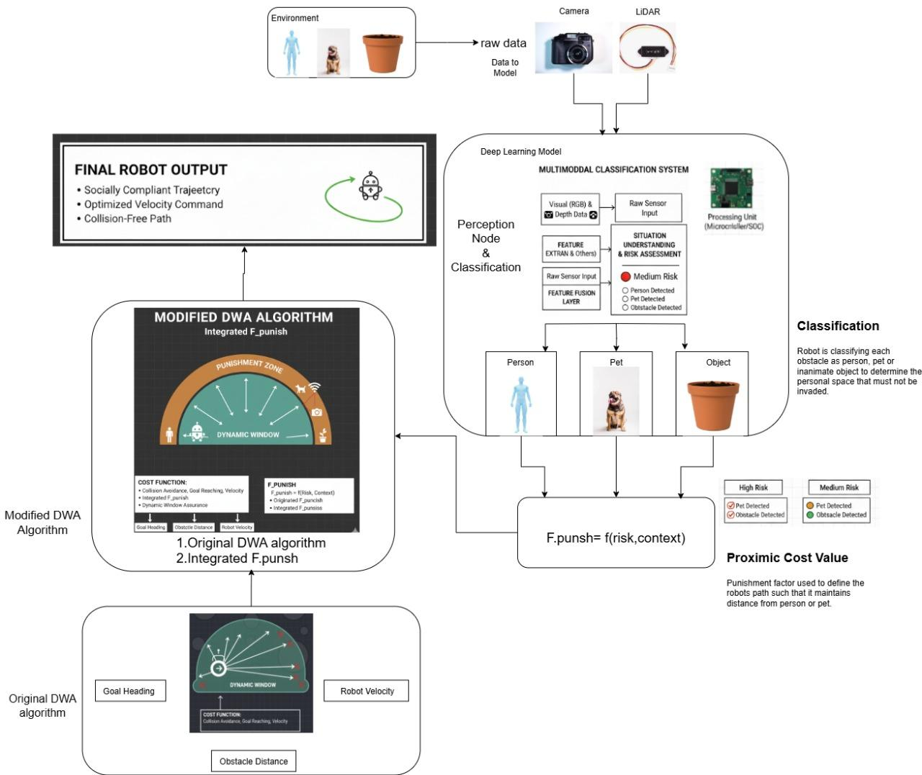

Fig 1. Proposed System architecture

- System Architecture and Data Flow
The overall architecture of our proposed system, implemented within a lightweight Python simulation environment, is conceptually illustrated in Figure 1. The process begins within the main simulation loop, which manages a 2D Environment containing a single Robot object and a list of Obstacle objects. Each Obstacle object is initialized with a position, a behavioral pattern, and a semantic .type attribute (e.g., 'person', 'pet', 'object'), which serves as its ground-truth classification. In place of a traditional sensor pipeline, our simulation provides the planner with direct access to this list of objects, allowing for a focused evaluation of the navigation logic itself. This list of classified obstacles is passed as a direct argument to the Modified DWA Planner function. By integrating our novel social disqualification rule, the planner evaluates potential trajectories for both geometric efficiency and social compliance based on each obstacle's semantic type. Finally, the optimal, socially-aware velocity command is returned from the function and used to update the Robot object's state, resulting in intelligent and considerate motion.
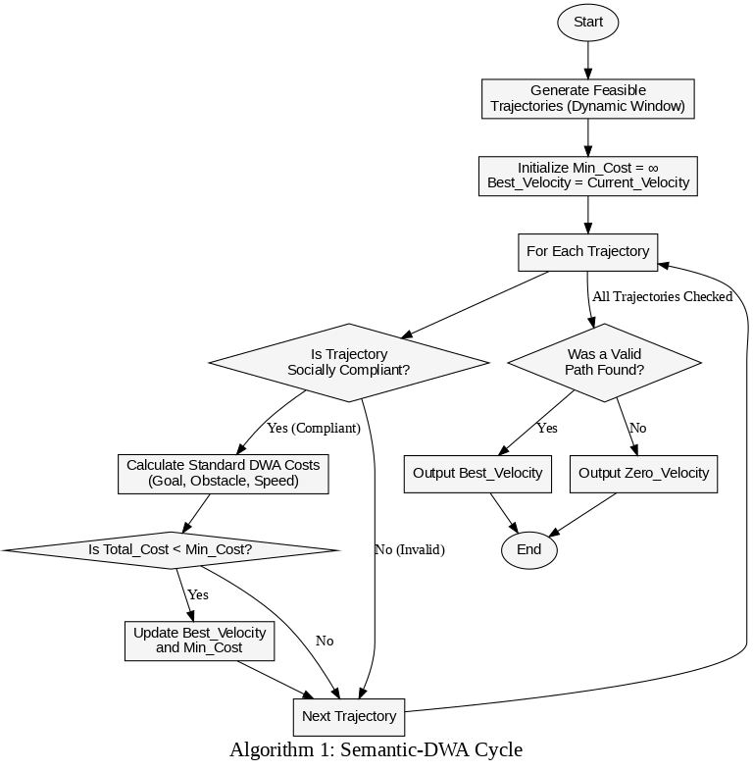
FIGURE 2. Dynamic window approach process flow
- Perception and Social Obstacle Classification
The perception and classification logic, detailed in the first stage of Algorithm 1, is an integrated function within the core planning loop rather than a separate background process. At the beginning of each planning cycle, the algorithm evaluates every potential trajectory against the ground-truth List_of_All_Obstacles present in the simulation. For each Obstacle object in this list, the function directly accesses its pre-defined .type attribute, which holds its semantic class (e.g., 'person', 'pet', 'object', or 'distractor').
This class information is then used to immediately apply the social disqualification rule. The algorithm calculates the minimum distance between the trajectory and the obstacle. If this distance falls below the specific threshold assigned to that obstacle's class (PERSON_THRESHOLD, PET_THRESHOLD, etc.), the trajectory is instantly assigned an infinite cost and is disqualified from further consideration. This "perfect perception" model, where the obstacle's class is known, allows our evaluation to focus purely on the behavioral outcome of the planning logic. By integrating perception and disqualification directly into the trajectory scoring loop, ensured that only socially and physically safe paths are ever considered for the final selection.
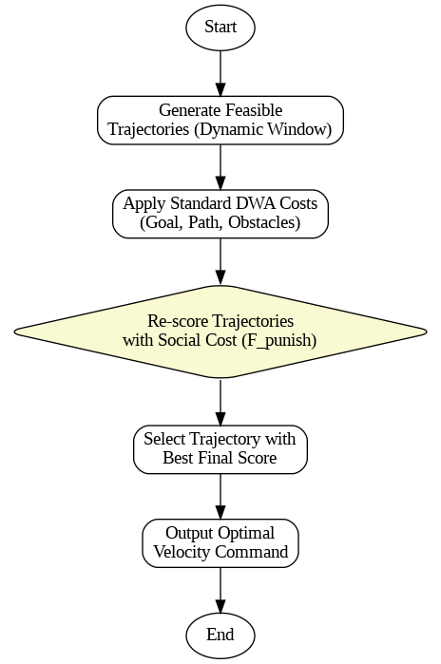
FIGURE 3. Semantic Enhanced-DWA Flowchart
- Socially-Aware Dynamic Window Approach (Semantic-DWA)
The core of our contribution lies in the Semantic-DWA planning logic, which is detailed in the main evaluation loop of Algorithm 1. The process begins by generating a "dynamic window" of all kinematically feasible trajectories the robot can take in a short time horizon. The novelty of our approach is applied immediately after generation: each potential trajectory is passed through a Social Disqualification filter. As shown in Algorithm 1, this filter uses the semantic class of each obstacle ('person', 'pet', etc.) to check for proxemic violations. If any point on a trajectory enters the predefined social threshold for any classified obstacle, that trajectory is instantly assigned an infinite cost and is disqualified from further consideration.
Only the trajectories that are deemed socially compliant (i.e., those that do not receive an infinite cost) are then evaluated by the standard DWA cost functions. This function scores the remaining valid trajectories based on traditional metrics like progress towards the goal, clearance from general obstacles, and forward velocity [1]. By filtering out socially unacceptable paths before the final selection, our method treats social rules as hard constraints, not mere suggestions. The planner then selects the best-scoring trajectory from the remaining valid set, ensuring the final output is a velocity command that is guaranteed to be both efficient and socially compliant.
- Mathematical Formulation
This section formalizes the cost functions that guide the planner's decision-making process. We first present the objective function of the classic DWA before detailing our novel social disqualification rule and its integration into the modified planner.

Traditional DWA Cost Function
The traditional Dynamic Window Approach (DWA) selects the optimal velocity command (v,ω) by scoring a set of feasible trajectories. The score for a given trajectory, G(v,ω), is a normalized, weighted sum of several competing objectives. The function is typically expressed as:
G(v,ω)=σ(α⋅heading(v,ω)+β⋅dist(v,ω)+γ⋅vel(v,ω)) (1)

where:
- v and ω are the linear and angular velocities.
- heading(v,ω) is the cost associated with the robot's alignment to the goal direction.
- dist(v,ω) is the cost representing the distance to the nearest obstacle.
- vel(v,ω) is a utility function that rewards maintaining a high forward velocity.
- α,β, and γ are weighting parameters that balance these objectives.
- σ is a normalization function to scale the total score.
As shown in Equation 1, this formulation is purely geometric and does not account for the semantic type of the obstacles it avoids.

Semantic-DWA Social Disqualification Rule
Our primary contribution is the replacement of a simple additive penalty with a Social Disqualification Rule, which applies a hard constraint based on the semantic class of an obstacle. Instead of calculating an additional penalty, we first determine if a trajectory is "socially compliant." A trajectory, traj, is considered compliant only if for all points p along it, the distance to every classified social obstacle o in the set Osocial​ is greater than or equal to the specific proxemic threshold D for that obstacle's type. This condition is expressed in Equation 2:
is_socially_compliant(traj)=∀o∈Osocial​,∀p∈traj:d(p,o)≥Do.type​ (2)
where Do.type​ is the predefined proxemic threshold (PERSON_THRESHOLD, PET_THRESHOLD, etc.) for the semantic class of obstacle o.
The final cost of the trajectory is then determined by a piecewise function that either applies the standard DWA cost or disqualifies the path entirely. This is shown in Equation 3:
Costmodified​(traj)={G(traj)∞​if is_socially_compliant(traj) is Trueif is_socially_compliant(traj) is False ​(3)As defined in Equation 3, any trajectory that violates a social threshold is immediately assigned an infinite cost, effectively removing it from consideration. The planner's task is then to find the trajectory with the minimum cost from the remaining, pre-filtered set of socially compliant options. This transforms the social rules from soft suggestions into hard constraints, guaranteeing compliant behavior whenever a valid path exists.
IV. Experimental Set up and Evaluation Metrics
To validate the efficacy and performance of our proposed Semantic-DWA framework, we conducted a series of comparative experiments within a lightweight, reproducible 2D simulation environment. The primary objective was to quantitatively and qualitatively assess our modified planner against the standard DWA.
- Experimental Setup
All experiments were performed within a custom 2D simulation developed in Python 3 using the NumPy and Matplotlib libraries, executed in a Google Colab environment. This approach allows for a focused evaluation of the planner's core logic, isolated from the complexities of a full 3D physics engine.
- Simulation Environment: The environment consists of a 20x20 meter open space. The robot is tasked with navigating from a start position of (2.0, 2.0) to a goal position of (18.0, 18.0).
- Obstacle Configuration: The environment contains four distinct obstacles designed to test the planner's ability to handle different types of interactions:
  - A 'person' obstacle that patrols vertically.
  - A 'pet' obstacle that moves sporadically in a non-linear path.
  - A static 'object' placed directly on the optimal path line.
  - A 'distractor' obstacle that patrols horizontally.
- Planner Configurations: Two planner configurations were compared:
  - Baseline (Standard DWA): The classic DWA algorithm, which scores trajectories based only on geometric cost functions (goal heading, obstacle distance, and velocity).
  - Proposed (Semantic-DWA): Our modified planner, which uses the "social disqualification rule," assigning an infinite cost to any trajectory that violates the predefined proxemic thresholds for each semantic obstacle class.
B. Evaluation Metrics
The performance of each planner was evaluated using the following metrics to measure safety, social compliance, and efficiency.
- Collision Detection (Safety): A binary metric to determine if the robot's physical body (defined by a 0.5m radius) intersected with any obstacle's position at any point during the simulation. A successful run must be collision-free.
- Minimum Clearance Distance (Social Compliance): The primary quantitative metric. We recorded the closest distance the robot's center point came to each of the four obstacles throughout its trajectory. This directly measures the planner's ability to respect predefined physical and social boundaries.
- Trajectory Visualization (Qualitative Analysis): The complete path of the robot and all obstacles was recorded and animated, allowing for a clear visual comparison of the navigation behaviors exhibited by each planner.
V. Results and Discussion
To validate our proposed Semantic-DWA framework, we conducted a comparative simulation study against the baseline Standard DWA. This section presents and analyzes the quantitative and qualitative results from these experiments, demonstrating the efficacy of our approach in producing socially compliant and safe navigation.
A. Baseline Performance: Standard DWA
The Standard DWA, relying on its purely geometric cost function, failed to safely navigate the complex social environment. The planner's aggressive, goal-oriented nature led to multiple critical failures. As shown in the results summary (Table 1), the simulation run resulted in three separate collisions, occurring with the 'Person', the 'Pet', and the static 'Object'. The recorded minimum clearance distances were well within the robot's 0.5m physical radius, with a mere 0.35m from the Person and 0.36m from the Pet. This failure is a direct consequence of the planner's inherent "social blindness"; it made 'greedy' decisions that prioritized the shortest path to the goal without a mechanism to account for the higher risk of dynamic social obstacles or even its own physical footprint in tight situations. The left panel of Figure 4 visually corroborates this, illustrating a direct, aggressive path that results in clear intersections with the obstacles.
B. Proposed Method Performance: Semantic-DWA
In stark contrast, the Semantic-DWA successfully navigated the same cluttered scenario with zero collisions. The results show a dramatic improvement in both safety and social compliance. The minimum clearance from the Person was 1.00m and from the Pet was 2.08m, both safely outside the robot's physical radius and demonstrating a clear respect for their defined social zones. This success is directly attributed to the Social Disqualification Rule detailed in our methodology (Equation 3). By treating the proxemic thresholds as hard constraints and assigning an infinite cost to any violating trajectory, the planner's decision space was fundamentally altered. It was forced to filter out all socially and physically unsafe paths before the final optimization, guaranteeing the selection of a compliant maneuver. The right panel of Figure 4 clearly illustrates this intelligent behavior, showing the robot executing a deliberate, wide arc to avoid the social obstacles.
C. Comparative Analysis
The quantitative data, summarized in Table 1, provides a clear and compelling comparison between the two approaches.
Metric / Obstacle | Standard DWA | Semantic-DWA (Proposed)
Collisions Detected | YES (3) | NO (0)
Min Clearance: Person | 0.35m | 1.00m
Min Clearance: Pet | 0.36m | 2.08m
Min Clearance: Object | 0.47m | 0.87m
Min Clearance: Distractor | 1.74m | 0.76m
TABLE 1. Summary of performance metrics.

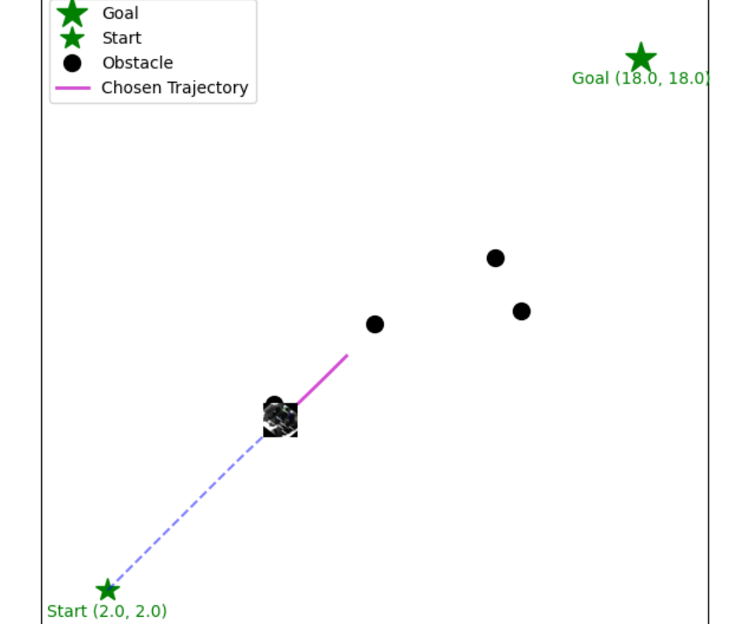 | 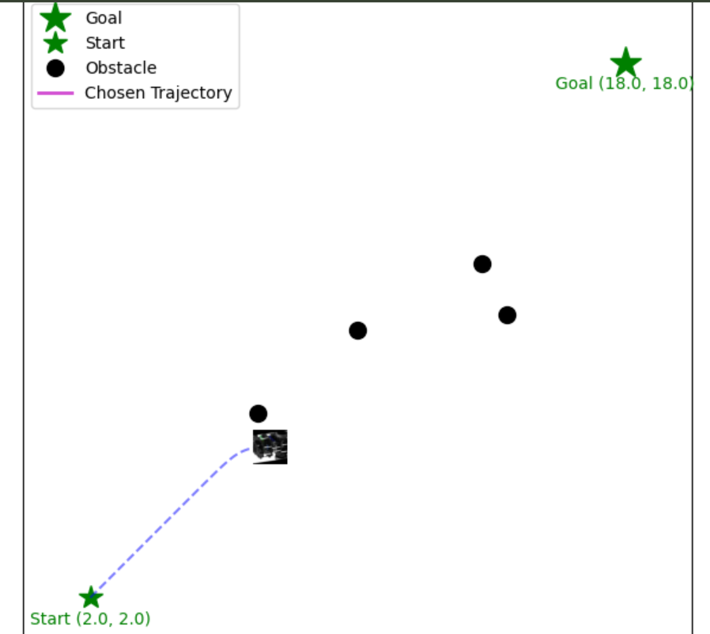
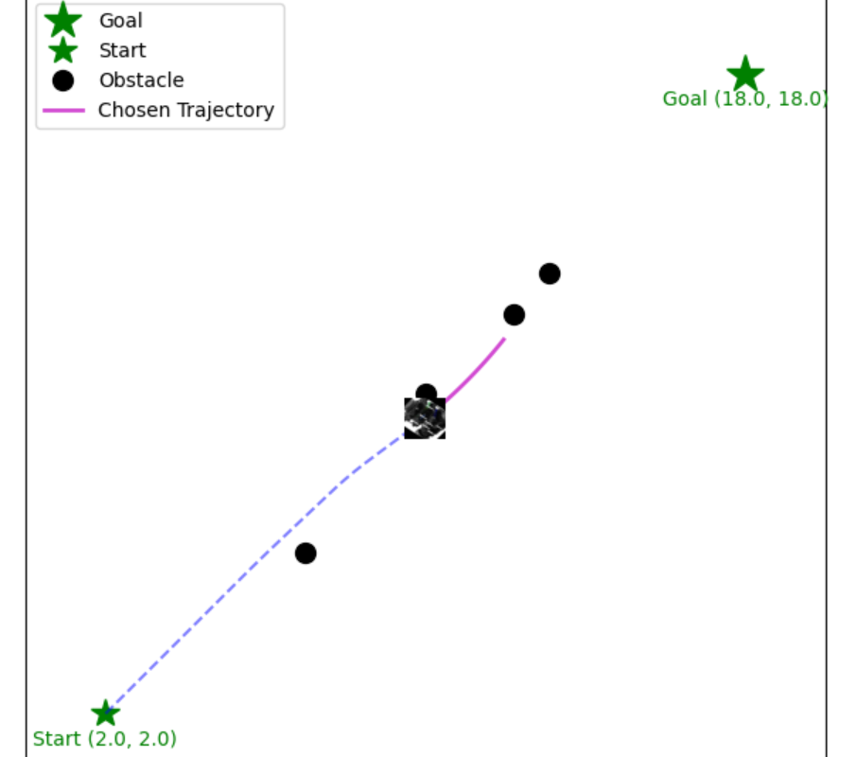 | 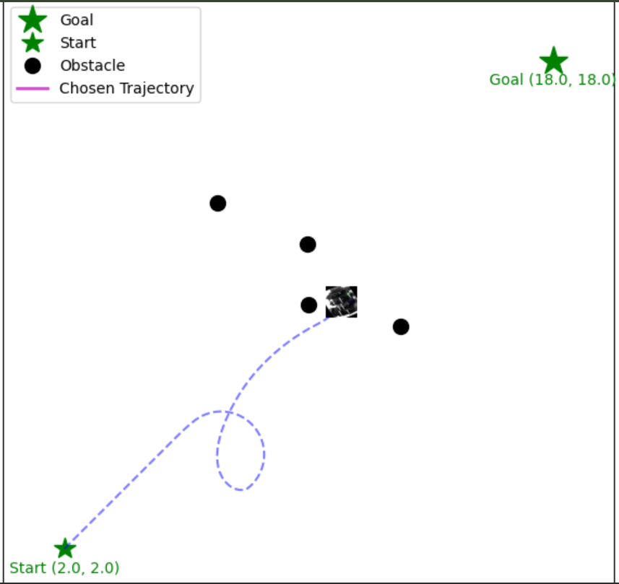
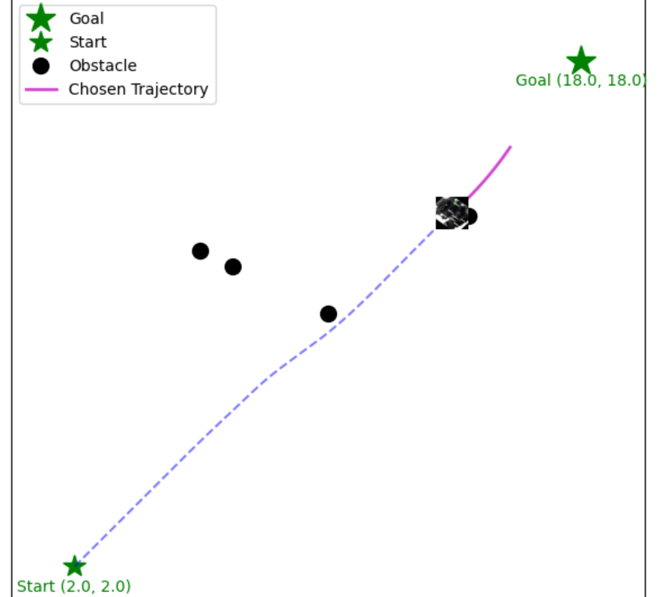 | 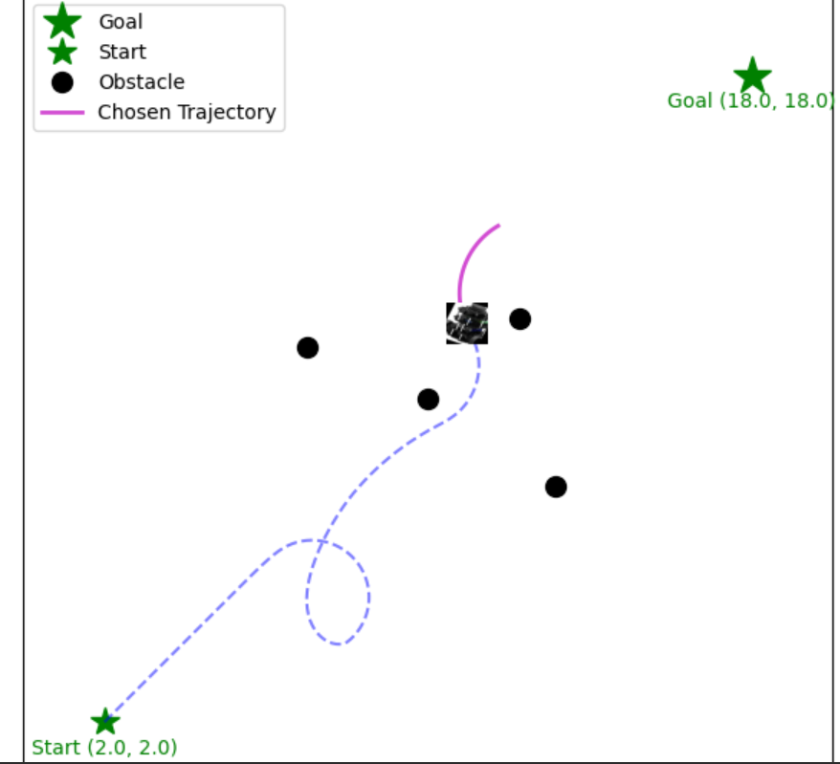
FIGURE 4. Comparison of Standard DWA and our Semantic (context-aware) DWA in collision avoidance ( Left: Standard DWA. Right: Semantic (context-aware) DWA

The Semantic-DWA not only eliminated all collisions but also increased the minimum clearance from the Person by over 185% and from the Pet by over 470%. Crucially, the results also demonstrate the algorithm's ability to exhibit differentiated behavior. The planner maintained the largest clearance for the highest-risk 'Pet' (2.08m), a moderate clearance for the 'Person' (1.00m), and a much tighter, more efficient clearance for the inanimate 'Object' (0.87m) and 'Distractor' (0.76m). This proves that the planner is not simply being "more cautious" overall; it is intelligently applying different, context-specific social rules to different semantic classes, which was a primary objective of this work. In summary, the experimental results quantitatively and qualitatively validate our hypothesis, proving that the Semantic-DWA framework demonstrably and reliably outperforms the standard DWA in a cluttered social environment.

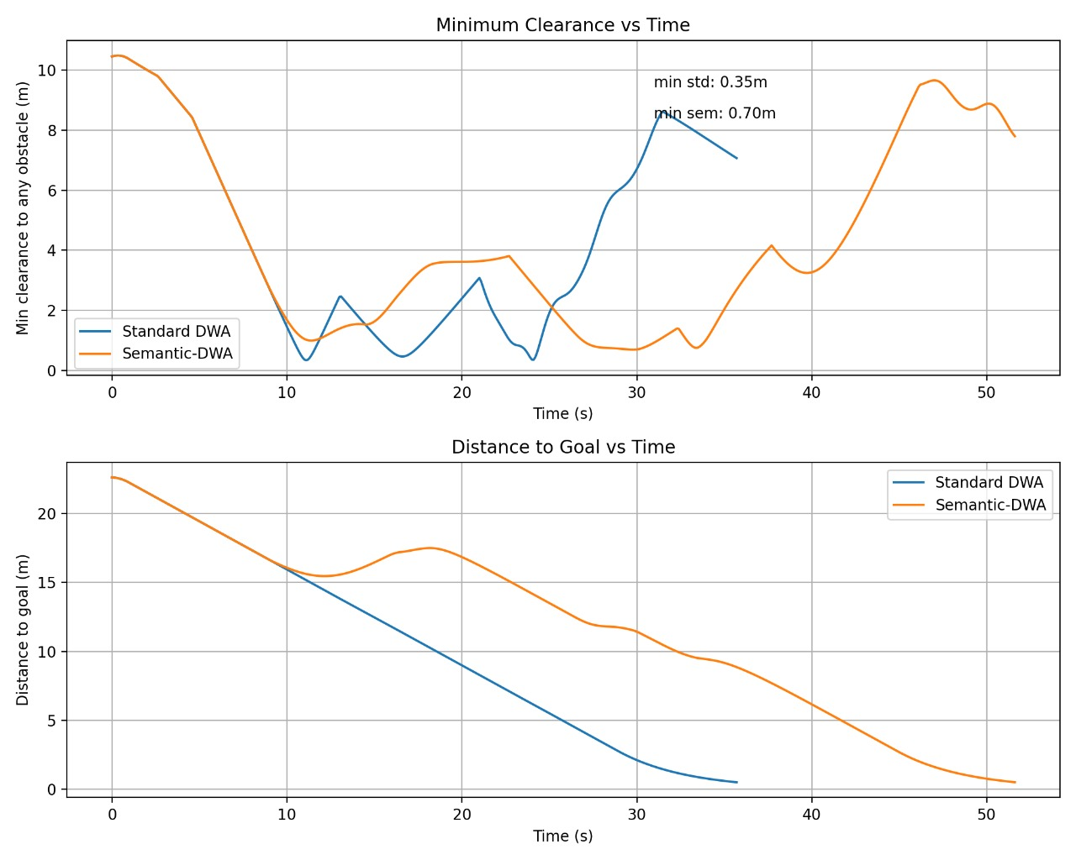

VI. Conclusion
This paper addressed the critical limitation of classic, geometry-based local planners in socially complex environments. We demonstrated that the standard Dynamic Window Approach (DWA), while efficient, fails to produce safe or socially acceptable behavior in the presence of dynamic and static social obstacles, resulting in multiple collisions in our test scenario.
To solve this, we proposed and validated Semantic-DWA, a novel framework that augments the classic planner with a lightweight, interpretable layer of social intelligence. Our methodology, successfully demonstrated in a custom Python simulation, integrates a semantic perception function with a Social Disqualification Rule. By treating proxemic zones as hard constraints and immediately disqualifying any trajectory that violates the predefined

personal space of 'persons', 'pets', or other objects, our algorithm fundamentally changes the planner's decision-making process.
The results quantitatively prove the efficacy of our approach. The Semantic-DWA successfully navigated the cluttered social environment with zero collisions, a stark contrast to the baseline planner's repeated failures. More importantly, it exhibited differentiated, intelligent behavior, maintaining a significantly larger clearance from high-risk dynamic obstacles than from static ones. The primary contribution of this work is a computationally tractable and easily verifiable method for achieving robust social compliance. It serves as a successful proof-of-concept, demonstrating that by augmenting proven, reliable planners with semantic context, we can develop autonomous systems that are not only safer but also more intuitive and acceptable for coexistence in shared human-robot environments.

APPENDIX
The Data files for all code used in this research and related fields are available on this GitHub repository.
GitHub repository link:
https://github.com/Ashwath-Shivram-22BAI1188/22BAI1188_ASHWATH_SHIVRAM_22BAI1118_MAYANK_RAJ

REFERENCES

[1] Jang, J., and Ghaffari, M. "Social Zone as a Barrier Function for Socially-Compliant Robot Navigation." IFAC-PapersOnLine, 58(30):157-162, 2024. DOI: https://doi.org/10.1016/j.ifacol.2025.01.173
[2] Dong, Y., van Arem, B., and Farah, H. "Toward developing socially compliant automated vehicles: Advances, expert insights, and a conceptual framework." Communications in Transportation Research, 5:100207, 2025. DOI: https://doi.org/10.1016/j.commtr.2025.100207
[3] Lamichhane, B. R., et al. "Context-aware decision making in autonomous vehicles: Integrating social behavior modeling with large language models." Array, 27:100420, 2025. DOI: https://doi.org/10.1016/j.array.2025.100420
[4] Shibata, K., et al. "Collision-free Navigation with Unknown and Heterogeneous Social Preferences." IFAC-PapersOnLine, 56(2):11429-11435, 2023. DOI: https://doi.org/10.1016/j.ifacol.2023.10.430
[5] Boldrer, M., et al. "Multi-agent navigation in human-shared environments: A safe and socially-aware approach." Robotics and Autonomous Systems, 149:103979, 2022. DOI: https://doi.org/10.1016/j.robot.2021.103979
[6] Banda, L. G., and Chandra, S. "Natural intelligence in autonomous vehicles: Redefining the path to human-centric adoption." Journal of Retailing and Consumer Services, 84:104195, 2025. DOI: https://doi.org/10.1016/j.jretconser.2024.104195
[7] Alozi, A. R., and Hussein, M. "How do active road users act around autonomous vehicles? An inverse reinforcement learning approach." Transportation Research Part C: Emerging Technologies, 161:104572, 2024. DOI: https://doi.org/10.1016/j.trc.2024.104572
[8] Möller, R., et al. "A survey on human-aware robot navigation." Robotics and Autonomous Systems, 145:103837, 2021. DOI: https://doi.org/10.1016/j.robot.2021.103837
[9] Kim, Y., et al. "Understanding human-robot proxemic norms in construction: How do humans navigate around robots?." Automation in Construction, 164:105455, 2024. DOI: https://doi.org/10.1016/j.autcon.2024.105455
[10] Lanzaro, G., Sayed, T., and Fu, C. "A comparison of pedestrian behavior in interactions with autonomous and human-driven vehicles: An extreme value theory approach." Transportation Research Part F: Traffic Psychology and Behaviour, 99:1-18, 2023. DOI: https://doi.org/10.1016/j.trf.2023.10.006
[11] Luo, Y., et al. "Path planning for orchard mobile robots based on an improved ant colony algorithm and the dynamic window approach." Smart Agricultural Technology, 12:101518, 2025. DOI: https://doi.org/10.1016/j.atech.2025.101492
[12] Wang, J., et al. "Dynamic obstacle avoidance control based on a novel dynamic window approach for agricultural robots." Computers in Industry, 167:104272, 2025. DOI: https://doi.org/10.1016/j.compind.2025.104272
[13] Cao, Y., and Nor, N. M. "An improved dynamic window approach algorithm for dynamic obstacle avoidance in mobile robot formation." Decision Analytics Journal, 11:100471, 2024. DOI: https://doi.org/10.1016/j.dajour.2024.100471
[14] Yao, M., et al. "Improved dynamic windows approach based on energy consumption management and fuzzy logic control for local path planning of mobile robots." Computers & Industrial Engineering, 187:109767, 2024. DOI: https://doi.org/10.1016/j.cie.2023.109767
[15] Bes, J., et al. "DWA-3D: A reactive planner for robust and efficient autonomous UAV navigation in confined environments." Robotics and Autonomous Systems, p. 105196, 2025. DOI: https://doi.org/10.1016/j.robot.2025.105196
[16] He, J., et al. "Research on Adaptive Reward Optimization Method for Robot Navigation in Complex Dynamic Environment." Computers, Materials and Continua, 84(2):2733-2749, 2025. DOI: https://doi.org/10.32604/cmc.2025.065205
[17] Sivayazi, K., and Mannayee, G. "Modeling and simulation of a double DQN algorithm for dynamic obstacle avoidance in autonomous vehicle navigation." e-Prime - Advances in Electrical Engineering, Electronics and Energy, 8:100581, 2024. DOI: https://doi.org/10.1016/j.prime.2024.100581
[18] Huang, M., et al. "Uncertainty-aware deep distributed reinforcement learning for autonomous navigation of unmanned surface vehicles in complex environments." Ocean Engineering, 342:122899, 2025. DOI: https://doi.org/10.1016/j.oceaneng.2025.122899
[19] Navone, A., et al. "GPS-free autonomous navigation in cluttered tree rows with deep semantic segmentation." Robotics and Autonomous Systems, 183:104854, 2025. DOI: https://doi.org/10.1016/j.robot.2024.104854
[20] Chen, N., et al. "Semantic SLAM using laser-vision data fusion: Enhancing autonomous navigation in unstructured environments." Alexandria Engineering Journal, 127:606-618, 2025. DOI: https://doi.org/10.1016/j.aej.2025.05.015
[21] Luo, Y., et al. "A navigation line extraction method based on semantic segmentation and centerline fitting." Smart Agricultural Technology, 12:101492, 2025. DOI: https://doi.org/10.1016/j.atech.2025.101492
[22] Hu, D., and Gan, V. J. "Semantic navigation for automated robotic inspection and indoor environment quality monitoring." Automation in Construction, 170:105949, 2025. DOI: https://doi.org/10.1016/j.autcon.2024.105949
[23] Thyri, E. H., and Breivik, M. "Partly COLREGs-compliant collision avoidance for ASVs using encounter-specific velocity obstacles." IFAC-PapersOnLine, 55(31):37-43, 2022. DOI: https://doi.org/10.1016/j.ifacol.2022.10.406
[24] Tran, T.-H., Pralet, C., and Fargier, H. "Route recombination for deterministic and non-deterministic orienteering problems with time windows: A dynamic programming approach." Computers & Operations Research, 167:106663, 2024. DOI: https://doi.org/10.1016/j.cor.2024.106663
[25] Lin, S.-L., and Lin, B.-C. "Enhancing Safety in Autonomous Vehicle Navigation: An Optimized Path Planning Approach Leveraging Model Predictive Control." Computers, Materials and Continua, 80(3):3555-3572, 2024. DOI: https://doi.org/10.32604/cmc.2024.055456
[26] Kretzschmar, H., Spies, M., Sprunk, C., and Burgard, W. "Socially Compliant Mobile Robot Navigation via Inverse Reinforcement Learning." The International Journal of Robotics Research, 35(11):1327-1342, 2020. DOI: https://doi.org/10.1177/0278364916629272

[27] Kretzschmar, H., Kuderer, M., Sprunk, C., and Burgard, W. "Feature-Based Prediction of Trajectories for Socially Compliant Navigation." The International Journal of Robotics Research, 37(12):1478-1490, 2020. DOI: https://doi.org/10.1177/0278364918790352

[28] Song, D., Liang, J., Payandeh, A., Raj, A. H., Xiao, X., and Manocha, D. "VLM-Social-Nav: Socially Aware Robot Navigation Through Scoring Using Vision-Language Models." IEEE Robotics and Automation Letters, 10(1):508-515, 2025. DOI: https://doi.org/10.1109/LRA.2024.3411481

[29] Wang, F., Li, Z., Guo, S., Jiang, J., and Chen, B. "Semantic-assisted SLAM with Dynamic Obstacle Rejection for Autonomous Mobile Robots." Applied Sciences, 13(15):8695, 2023. DOI: https://doi.org/10.3390/app13158695

